**A PROJECT REPORT ON**

**Capstone Project Planning**

**DAIRY APPLICATION**

**UNDER THE GUIDANCE OF IN PARTIAL FULFILLMENT OF**

**DIPLOMA IN COMPUTER ENGINEERING MAHARASHTRA STATE BOARD OF TECHNICAL**



**EDUCATION VIDYA PRATISHTHAN’S POLYTECHNIC**

**Mr. Bhuse S. H Mr. Bhuse S.H Prof. Veer R.A.**

**PROJECT GUIDE HOD PRINCIPAL**

**ACKNOWLEDGEMENT**

After the successful planning of our project, we overcome with a sense of gratitude towards those people, without whose support, guidance and cooperation this would never have been possible.

First and foremost, we would like to thanks our **H.O.D. Mr. Bhuse S. H.** for his valuable guidance which provided us with a perfect path on which we were able to successful planning our ideas.

We heartily like to thank our **Principal Mr. Veer R. A.** for their valuable support. Last but not least we would like to thank all our classmates and parents for their enthusiasm and great ideas.

**Submitted by**

**Kullkarni Samarth Rajmani 208909**

**Pansare Uday Milind 208900**

**ABSTRACT**

In old days paper is used for maintaining or keeping records of milk in dairy. But now days it is very difficult to maintain or keep records on notebook. Also there will be possibility of loss of record and there is more load on dairy owners for maintaining records of milk. So our aim is to built the software to maintain or keep records of milk in dairy. We are going to do the project on Dairy Application to avoid work load on dairy owner that is record maintaining on notebook, payment calculation of members. There is need of dairy application for dairy owner to make record of each member. It is useful for dairy owners to check quantity and quality (fat, degree, snf) of members. Need of dairy application software is for easy calculation of payment of members. Also we calculate the payment of per day, as well as month. With the help of this software we can give the print of payment as well as per day. Also calculate the how much quantity of milk of month in liters. Also we maintain the record of food. We provide the Report & each member account facility. If new members are added in the dairy or removed then in this software we provide new entry & delete entry facility. Our software maintains a database on the computer for member details like membership number, date and time of the milk collection, weight of the milk, fat content of the milk and amount payable. Each milk collection society provides cattle feed. Our software is innovative and user-friendly management software that will help you optimize the performance of your dairy and beef cattle farm and increase your productivity. Our software gives you decision-making tools with fast, easy data entry, and flexible yet powerful reporting.

**CHAPATER 1**

**1.1 Introduction of project :-**

The project is on dairy application software. Our aim is to develop the software that is helpful to dairy holder.As we start the application first authentication form will appear in that user has to give user ID and password. After successful login next form will appear that contain date and selection of morning or evening collection. That form also includes user accounts. Next form provides section of milk collection, feed management, and member accounts. After clicking on milk collection our main form for daily milk collection will appear that contain various fields i.e. user ID, name, quantity of milk in liter, fat of milk, degree of milk, SNF etc. when we enter this information and press enter button this information will be save in database and printed receipt or report of that milk will be produced.

**1.2 Problem Definition :-**

Our software is a complete desk-top computer record keeping and management system for dairy.Main idea of the project is to built the software for maintaining records of milk, payment, feed, members etc. in milk dairy

**1.3 Scope Of Project :-**

* Helpful to maintaining records of each member.
* Easy calculation of payment.
* Daily report facility
* Saves times of user and reduce work load on dairy holder.

**CHAPATER 2**

**2.1 Literature Survey /Comparison with Similar System :-**

There is need of dairy application for dairy owner to make record of each member. It is useful for dairy owners to check quantity and quality (fat, degree, snf) of members. Need of dairy application software is for easy calculation of payment of members.Also we calculate the payment of per day, as well as month. With the help of this software we can give the print of payment as well as per day. Also calculate the how much quantity of milk of month in liters. Also we maintain the record of food. We provide the Report & each member account facility. If new members are added in the dairy or removed then in this software we provide new entry & delete entry facility. Our software maintains a database on the computer for member details like membership number, date and time of the milk collection, weight of the milk, fat content of the milk and amount payable. Each milk collection society provides cattle feed..Our software is innovative and userfriendly management software that will help you optimize the performance of your dairy and beef cattle farm and increase your productivity. Our software gives you decision-making tools with fast, easy data entry, and flexible yet powerful reporting.

**CAHAPTER 3**

* 1. **Objective of project-**
  2. **User Requirement-**
  3. **Hardware and Software Requirements-**

**Hardware :** 8gb ram

i5 processor

512gb SSD

**Software :** Windows 10

XAMPP Control Panel

Visual studio code

**CAHAPTER 4**

**4.0 System Design & Modelling :**

**Use Case Diagram :**

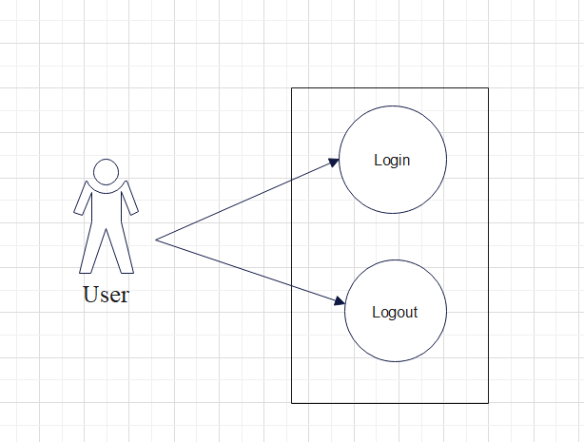

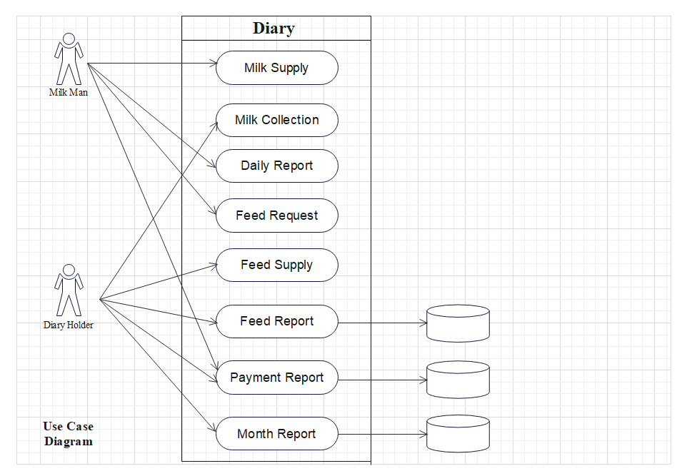

**Data Flow Diagram :**

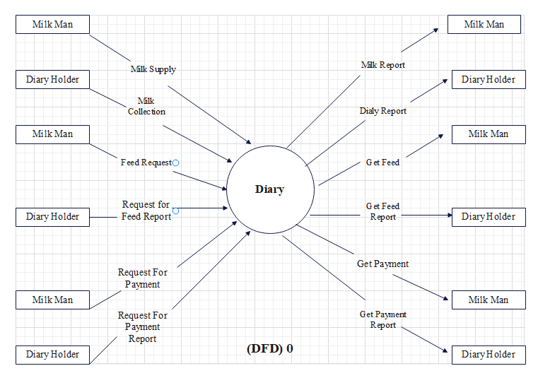

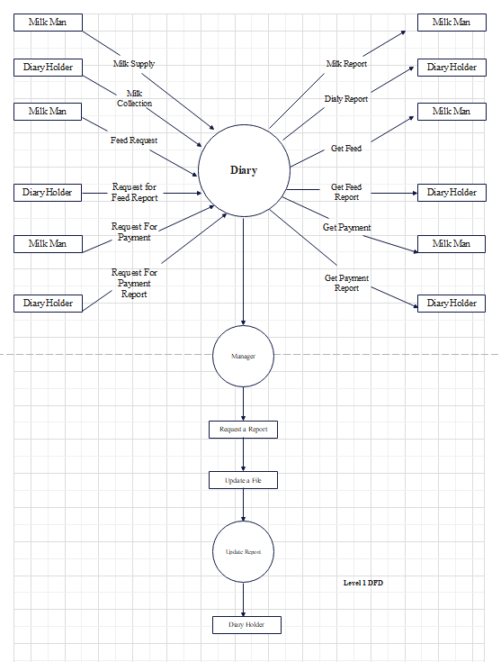

**Sequence Diagram :**

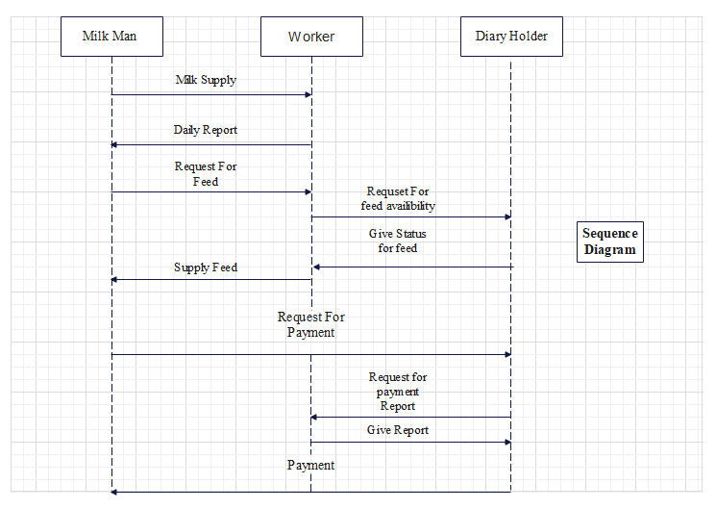

**Activity Diagram :**

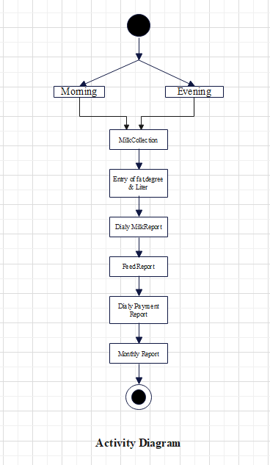

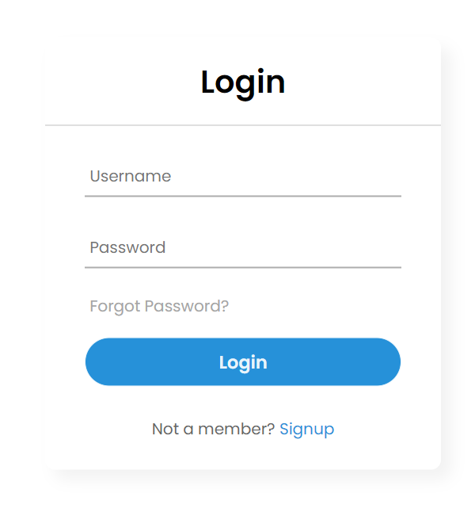

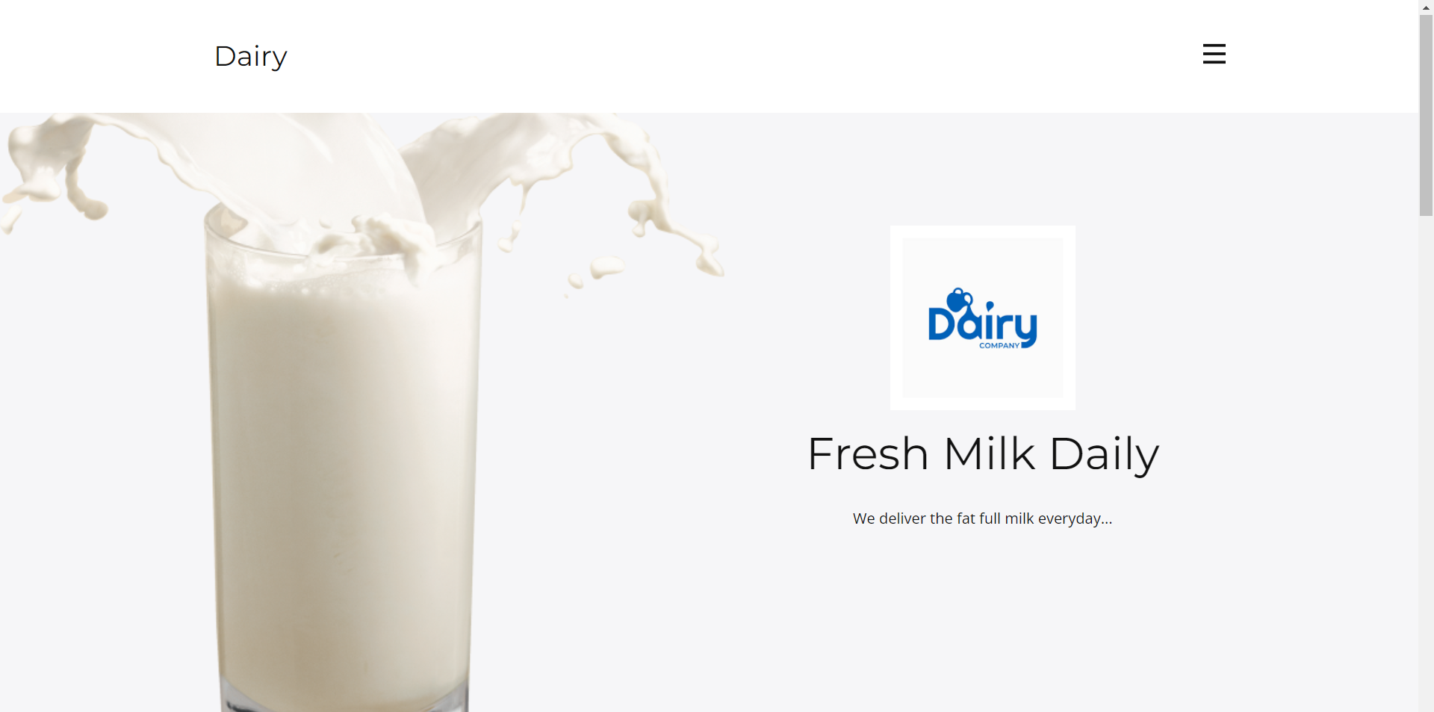

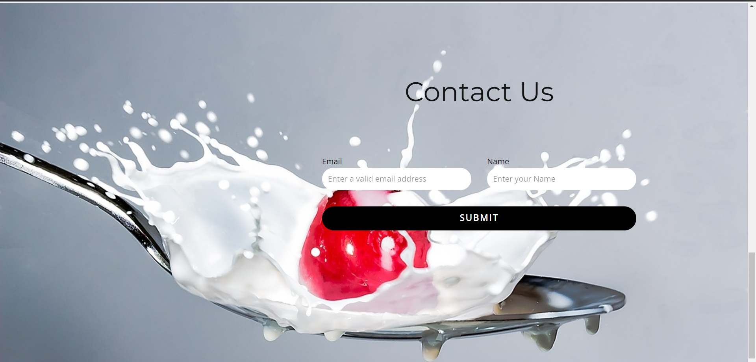

**CAHAPTER 5**

* 1. **Future Scope :**
  2. **Limitation :**
* It can only use at Dairy places.
* It can not be used at industry level.
* It can be upgrade as they want to add features.

**CAHAPTER 6**

* 1. **Books Referred :**

* 1. **Web References :**

<https://meridairy.in/index.html>

https://liter.live/#

**Conclusion :**